OFSAA SCENARIO DEBUGGER — PROJECT OVERVIEW
  - Version 1.0.0

WHAT IS THIS TOOL?

The OFSAA Scenario Debugger is an internal web application built to help the team investigate why an OFSAA alert scenario is NOT generating alerts.

When a scenario runs in OFSAA and produces no alerts, the usual process is manual — someone opens the log file, reads the SQL, runs queries in a database client, and tries to figure out which condition is filtering out all the data. This can take hours per scenario.

This tool automates that entire process. You upload the scenario log file, click Run, and within minutes the system tells you exactly which part of the SQL is the problem — and why.

THE PROBLEM IT SOLVES

OFSAA scenarios are built using a chain of SQL queries called CTEs (Common Table Expressions). Each CTE feeds data into the next, like a production line. If any one CTE returns zero rows, no alert is generated.

Example chain:
Loan data --> Customer filter --> Risk filter --> Alert

If "Risk filter" returns zero rows, the alert never fires. But why?
- Is the data just not there?
- Is a threshold (like minimum risk level) set too high?
- Is a date filter cutting out all records?

Without this tool, answering that question means running each CTE manually in a database tool — one by one — until you find the empty one, then digging further to find the specific condition causing it.

This tool does all of that automatically and presents the findings in a clear, visual interface.

HOW IT WORKS — STEP BY STEP

STEP 1 — Upload the Log File
The user uploads the OFSAA scenario execution log file (.log) through the web interface. No database access is needed at this stage.

STEP 2 — Read the Log
The system reads the log file and extracts:
- The scenario name (Job Description)
- The business date the scenario ran on
- The full SQL query that OFSAA executed

STEP 3 — Set the Batch Date
The system identifies which business date to use for the analysis (matching the date from the original log, not today's date).

STEP 4 — Execute the Dataset Query
The main SQL query is run against the Oracle database to confirm the data environment and establish a baseline.

STEP 5 — Parse the CTEs
The SQL is broken down into its individual building blocks (CTEs).
Each block is saved separately so it can be tested in isolation.

STEP 6 — Execute Each CTE One by One
Each CTE is run against Oracle as a database view. The system checks whether it returns rows or not.
- If a CTE returns rows: move to the next one
- If a CTE returns ZERO rows: this is the problem point

STEP 7 — Diagnose the Failing CTE
When a CTE returns zero rows, the system digs in automatically:

a) DATA UNAVAILABILITY CHECK
Checks if the source tables have any data at all. If a JOIN is eliminating all rows (no matching keys between tables), or if the date range filter has no data in it, this is flagged.

b) THRESHOLD ANALYSIS
Checks if a numeric condition (like "risk score >= 9") is set too high or too low compared to the actual data in the database.
The system queries the actual MIN, MAX, and distribution of the column and tells you what value the threshold needs to be.

c) ACTIONABLE SUGGESTION
For each finding, the system gives a plain-English recommendation:
"Try reducing the Efctv_Risk_Lvl threshold to get results
and try again."

STEP 8 — Display Results
All findings are presented in a visual dashboard showing:
- Which CTE failed
- Why it failed (data issue vs. threshold issue)
- The exact SQL condition responsible
- Threshold suggestions with actual data ranges
- What to change in HRE to fix it

WHAT THE USER SEES

LOGIN SCREEN
Simple username/password login. Access is controlled by an admin.
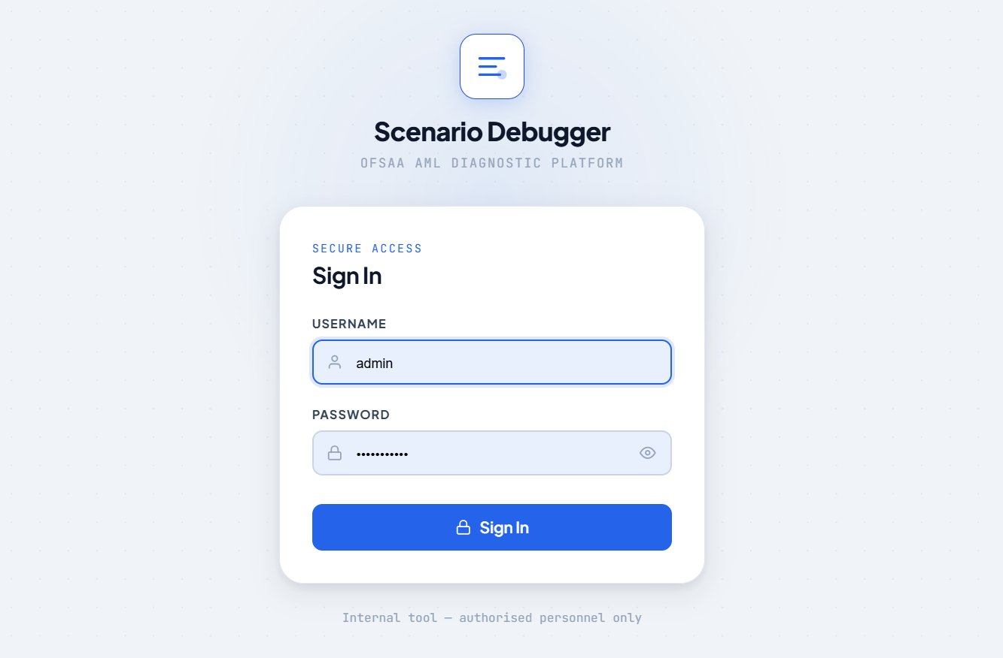
DASHBOARD
- Upload a log file or drag-and-drop
- Run multiple scenarios at once (batch mode)
- See history of all previous runs
- Results from a previous run are cached — re-opening the same
scenario instantly shows past results without re-running
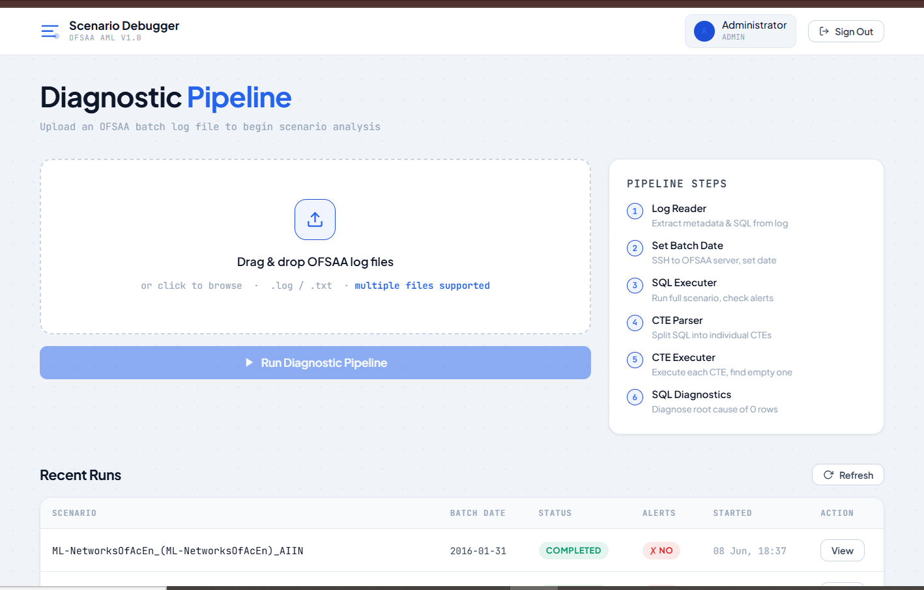

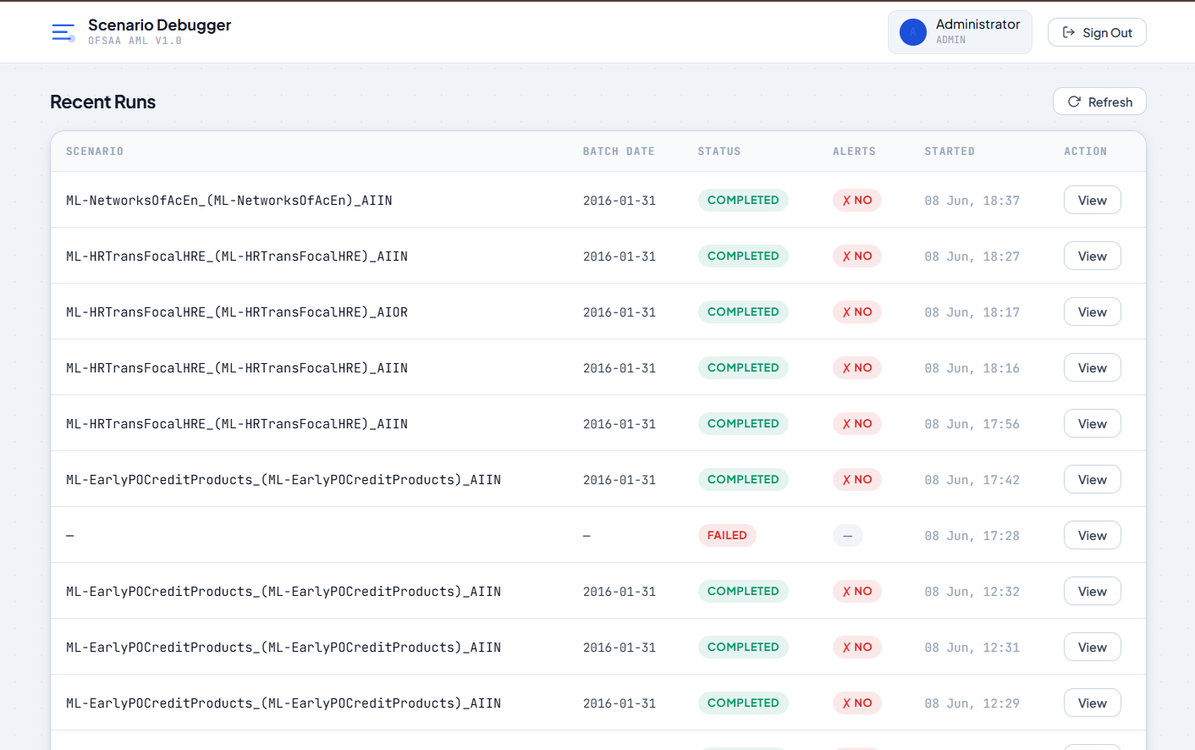

RESULTS SCREEN
- Live progress updates as the pipeline runs (Step 1 through 6)
- CTE waterfall: each CTE shown as a card with pass/fail status
- For the failing CTE: full diagnostic breakdown
- Threshold Suggestions panel showing:
Column name (HRE parameter name in brackets)
Current threshold value (e.g., >= 9)
Actual data range in the database
Plain-English fix suggestion
- Option to re-run with fresh data at any time
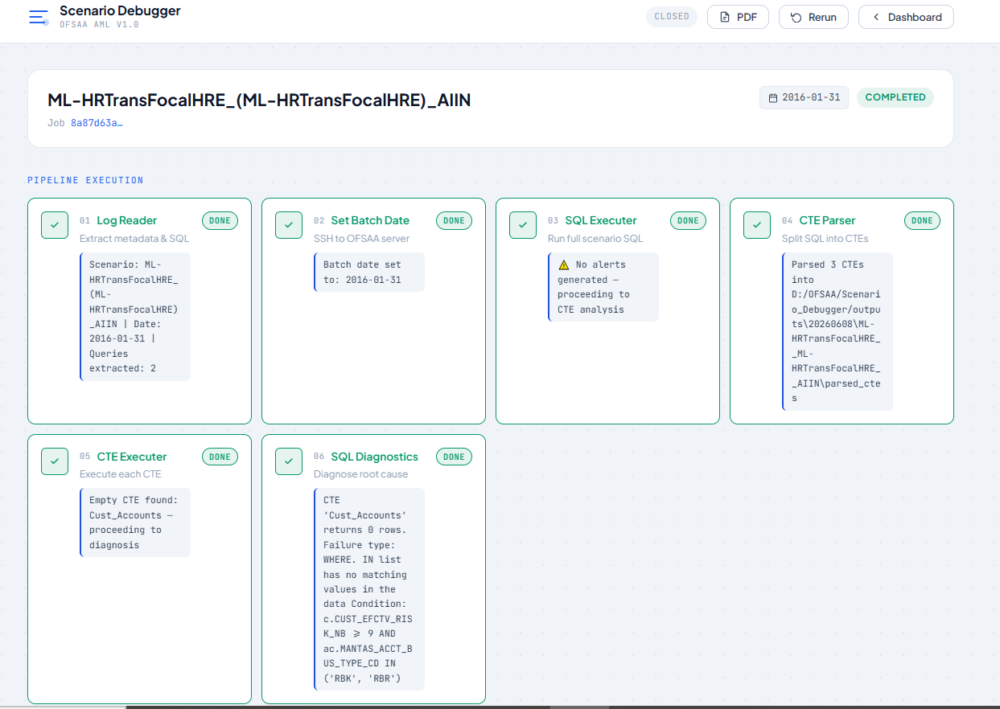
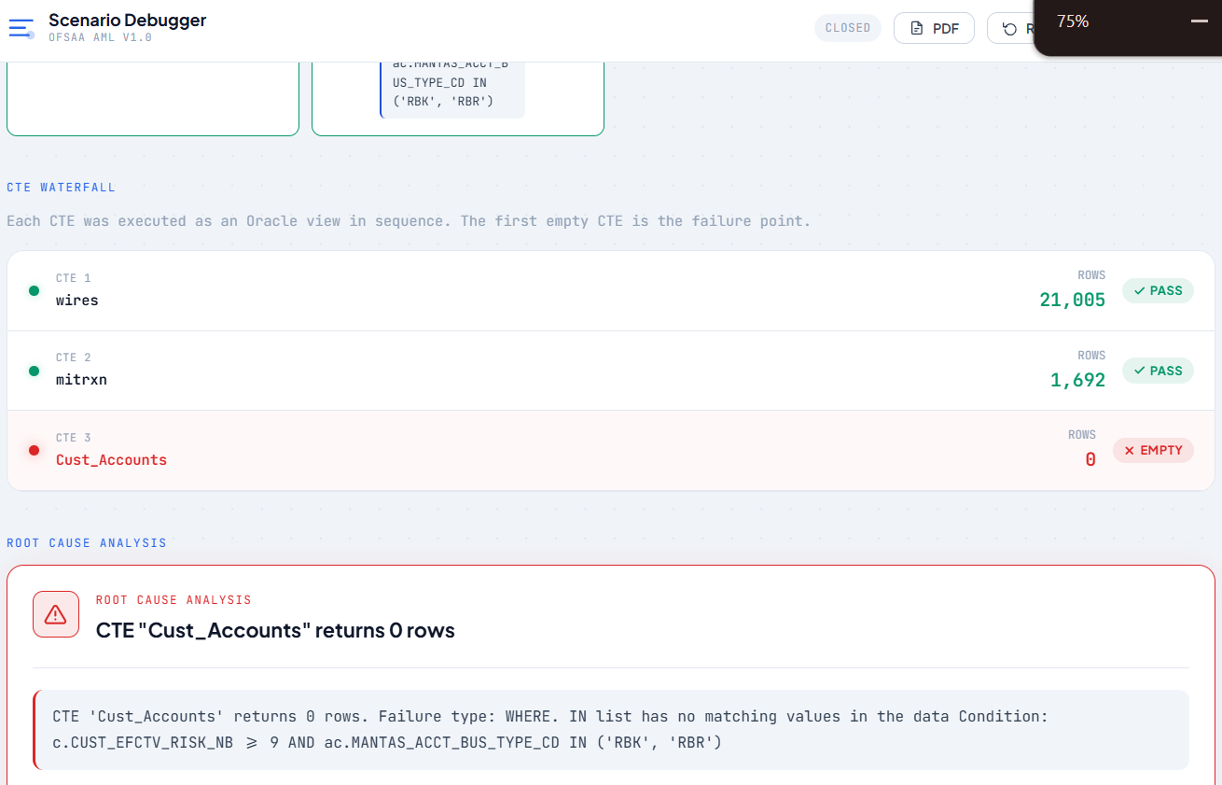
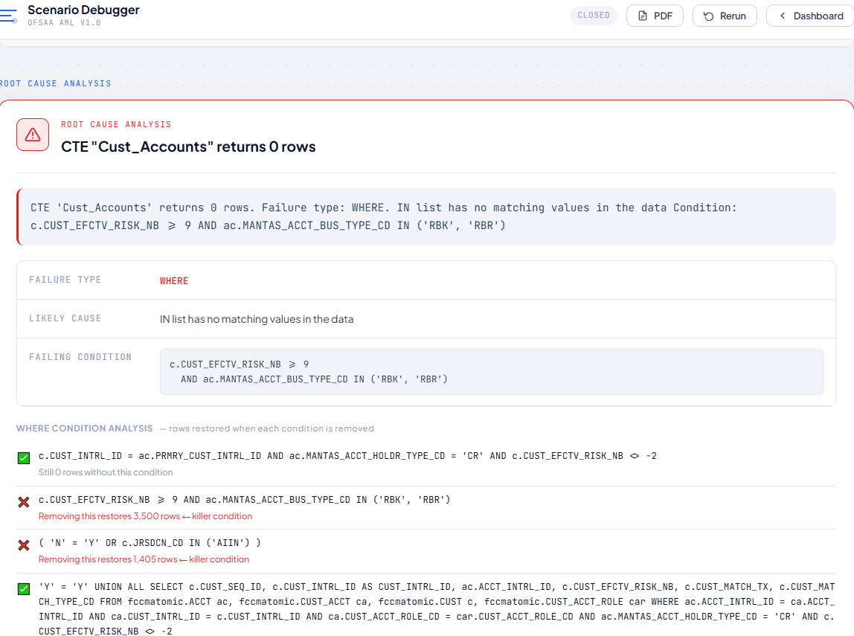
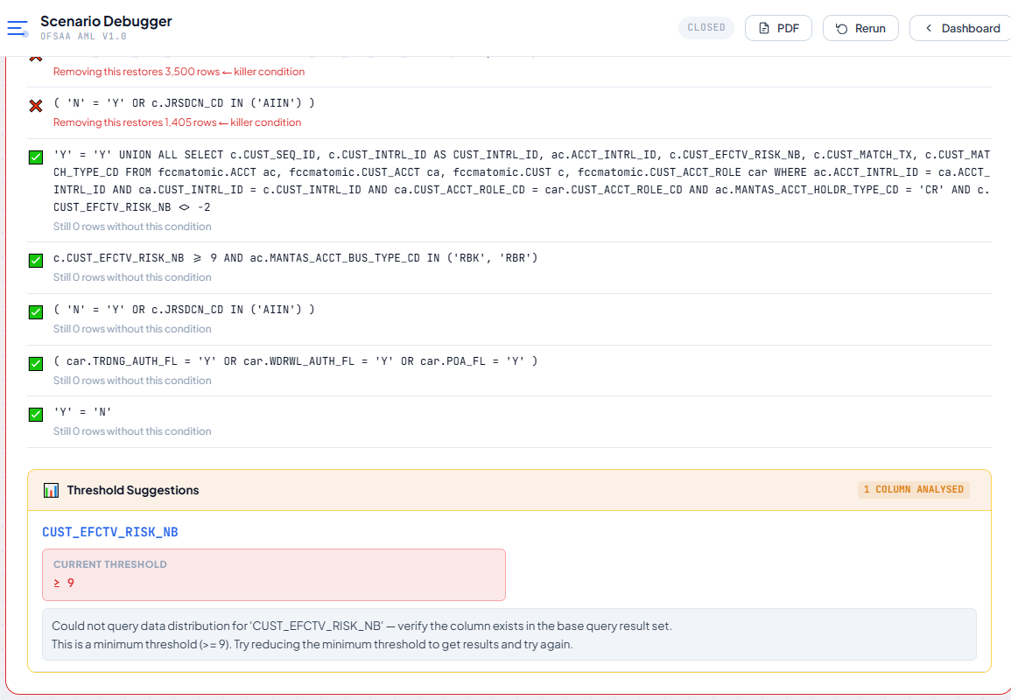

KEY FEATURES SUMMARY

Automated diagnosis No manual SQL running required
Real database queries Connects to the actual Oracle database (FCCMATOMIC)
CTE-level breakdown Pinpoints exactly which step in the chain fails
Threshold suggestions Shows actual data vs. current threshold setting
HRE parameter names Maps DB column conditions back to HRE config names (e.g., CUST_EFCTV_RISK_NB shown as Efctv_Risk_Lvl)
Batch processing Run multiple scenario logs at the same time
Result caching Previous results saved; re-run only when needed
Audit history Every run is logged with who ran it and when
User management Admin can add/remove users

TECHNOLOGY (FOR TECHNICAL REFERENCE)

Backend : Python (FastAPI) — runs on port 8000
Frontend : React 19 — runs on port 5173
Database : Oracle (FCCMATOMIC schema) + SQLite for app data
Start : Run "npm run dev" from the project root

The tool connects to Oracle in read-only mode.
It does not modify any OFSAA data — it only reads and diagnoses.

TYPICAL USE CASE

1. OFSAA runs overnight. An alert scenario produces zero alerts.
2. The analyst downloads the scenario log from OFSAA.
3. Analyst opens the Scenario Debugger in a browser.
4. Uploads the log file, clicks Run.
5. Within 1-2 minutes, the tool shows:
"CTE 'RiskFilter' returned 0 rows.
Condition: CUST_EFCTV_RISK_NB >= @Efctv_Risk_Lvl (currently 9)
Actual data range: 2 to 7
Try reducing the Efctv_Risk_Lvl threshold to get results
and try again."
6. Analyst adjusts the threshold in HRE and re-runs the scenario.

What previously took 2-3 hours of manual investigation now takes
under 5 minutes.

LIMITATIONS / WHAT IT DOES NOT DO

- It does not modify OFSAA, or any database settings.
It only reads and diagnoses — all fixes must be made in manually.

- It requires a live connection to the Oracle database to run the
diagnostic queries. It cannot work offline.

- It works on scenarios that use CTE-based SQL (which is the standard
OFSAA pattern). Non-standard SQL structures may not be fully diagnosed.

- Maximum log file size: 10 MB.

